**IBM CLOUD SERVICES**

* Simply put, cloud computing is the delivery of computing services— including servers, storage, databases, networking, software, analytics, and intelligence—over the Internet (“the cloud”) to offer faster innovation, flexible resources, and economies of scale.
* We need to have basic knowledge of the following cloud services:
  1. BM Watson IoT Platform, 2.Node-RED Service, 3.Cloudant DB,

4.TTS Service.

# Application modernization



* Unlock your core applications and harness cloud-native development to become a nimble market competitor.

# Automation:

* Reduce process blockers, improve IT operations, connect your apps and data, and tune network performance.

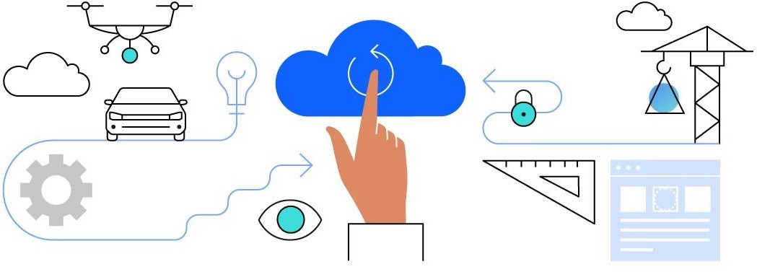

# Backup and disaster recovery:

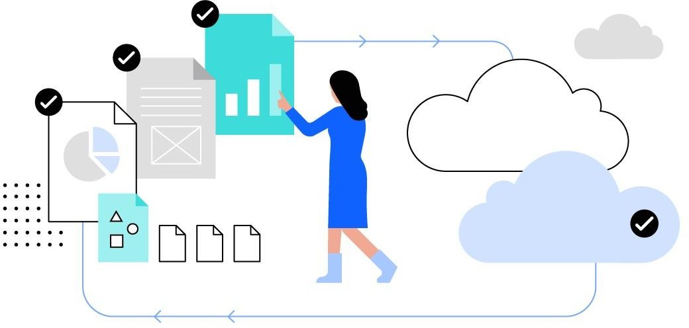

* Create a business continuity plan that includes cloud backup and disaster recovery for your critical IT systems.

# Confidential computing:

* Confidential computing protects sensitive data by performing computation in a hardware-based, trusted execution environment (TEE). You gain a higher level of privacy assurance with complete authority over your data at rest, in transit and in use.

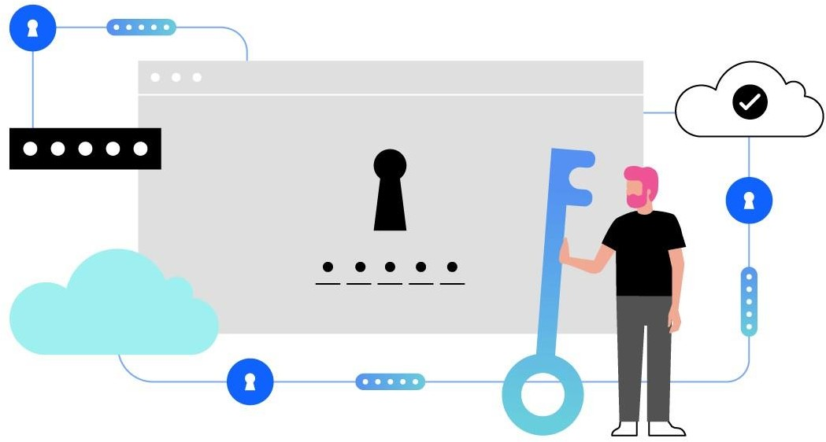

AND SO ON……

# ACCESSING CLOUD SERVICES:

